Data lake performance

Lab 5- Exploring table partitioning and bucketing

Estimated completion time
- 40 minutes

Learning objectives
- In this lab, you will explore how table partitioning and bucketing, used independently or together, can improve performance. You will see how both of these strategies will read far less data than a full scan of a table when there is a filter that aligns appropriately. You will understand the common strategy for creating a partition column that is derived from a more finite timestamp value.

Prerequisites
- Student setup - Lab 1: Create student account

Activities
- Prepare for the exercise
- Review partitioning & bucketing functionality
- Create a data lake table from TPCH orders table
- Locate metrics for data read
- Table scan orders searching by priority
- Create an orders table partitioned on priority
- Identify partition folders that were read
- Leverage partition pruning with partitioned orders table
- Using a partition column derived from a timestamp
- Table scan orders searching by customer
- Create an orders table bucketed on customer
- Read fewer files with bucketed orders table

Step 1 - Prepare for the exercise
- Sign in and verify the students role is selected in the upper-right corner.
- Ensure the aws-us-east-1-free Cluster is reporting a Status of Running.
- In the Query editor, select aws-us-east-1-free in the cluster pulldown.

Note: If you did not previously create a schema, execute the following SQL statement. Make sure that you replace yourname with your actual name, or another identifier that you prefer. Only use lowercase characters and numbers; no special characters or spaces.

CREATE SCHEMA students.yourname;

Step 2 - Review partitioning & bucketing functionality
Partitioning is just a way to divide data into subfolders. The field(s) you partition a table on become subfolders of the table’s data lake folder. When a WHERE clause is aligned to the partitioned field, then only the folder(s) that meet the particular criteria are read – the rest are ignored.

With bucketing you choose the number of buckets up front and this number if fixed. The values for each row for the bucketed field determine which bucket (a file) the row will consistently go into. When a WHERE clause is aligned to the bucketed field, then only the appropriate file(s) are read – the rest are ignored.

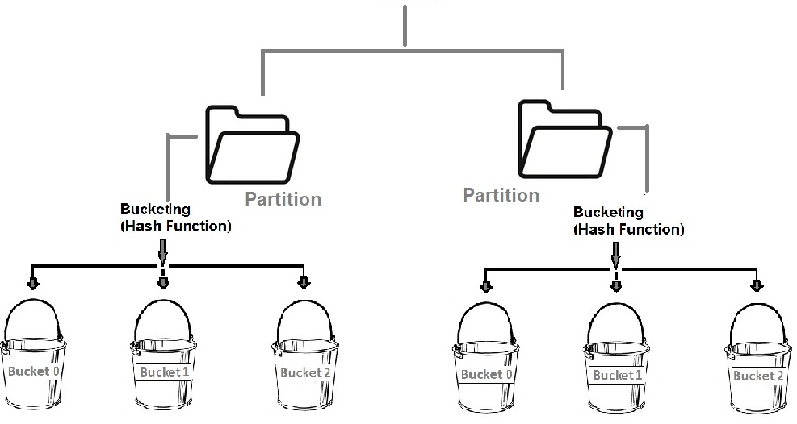

Partitioning and bucketing can be used together or by themselves.

Note: Be careful when creating small files using these features.

Step 3 - Create a data lake table from TPCH orders table
Run a CTAS statement to make a data lake table from the data present in the TCPH orders table.

USE students.yourname;

CREATE TABLE orders_no_pttn
WITH (
type = 'hive'
)
AS
SELECT *
FROM tpch.sf1.orders;

Verify that the following query returns 941 rows.

SELECT * from orders_no_pttn
WHERE totalprice >= 430000.00;

Step 4 - Locate metrics for data read
Click the Query details icon between the query editor pane and the query results pane.

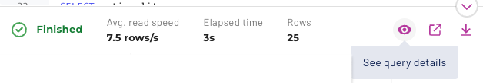

Click on the Advanced tab below the Query ID: label.

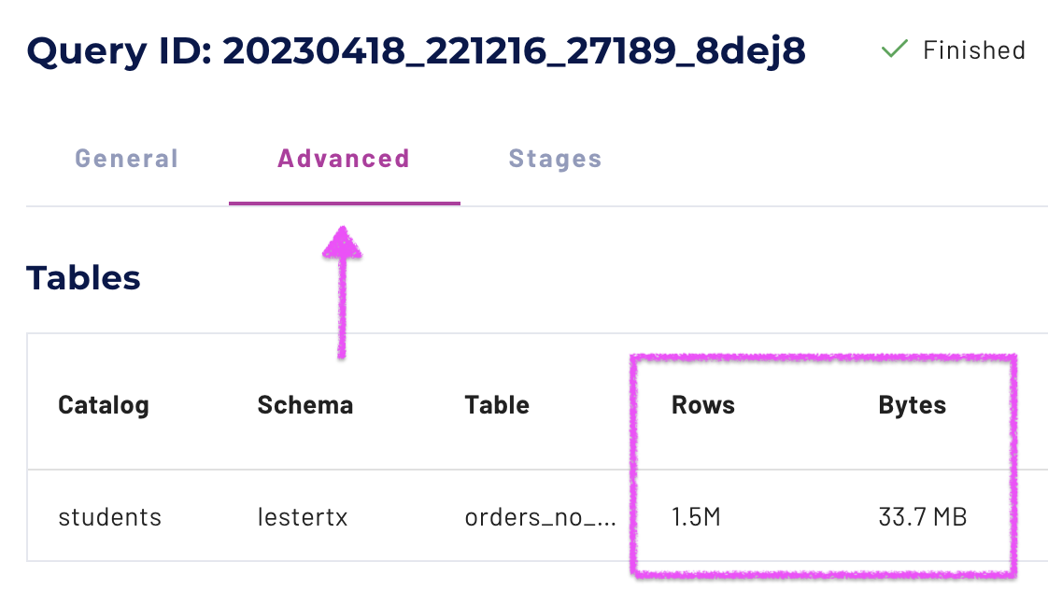

In the Tables section of the Advanced tab you will see values for number of Rows, and the Bytes, read.

For the last query in Step 3, all rows (1.5M) were read from the order_no_pttn table which accounted for 33.7MB of data. For this table, that equated to a full table scan of all records from the data lake.

Step 5 - Table scan orders searching by priority
Enhance the query filtering on the order’s priority field with the following query that returns 187 rows.

SELECT * from orders_no_pttn
WHERE totalprice >= 430000.00
AND orderpriority = '4-NOT SPECIFIED';

Using the process described in Step 4, verify that a full table scan occurred of all 1.5M rows and 33.7MB of data.

Step 6 - Create an orders table partitioned on priority
To create another version of the orders table using the priority field for the partitioning strategy, modify the CTAS statement from Step 3. Enhance it with the appropriate partitioned_by value.

CREATE TABLE orders_pttn_priority
WITH (
partitioned_by = ARRAY['orderpriority'],
type = 'hive'
)
AS
SELECT *
FROM tpch.sf1.orders;

You will receive the following error.

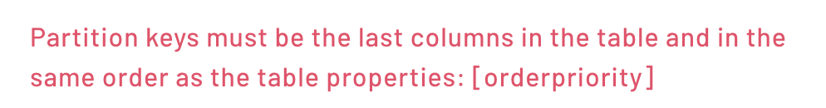

Just as it states, the partition field needs to be the last column in this (Hive) table.

Execute the following statement that reorders the columns so that orderpriority is last.

CREATE TABLE orders_pttn_priority
WITH (
partitioned_by = ARRAY['orderpriority'],
type = 'hive'
)
AS
SELECT orderkey, custkey, orderstatus, totalprice,
orderdate, clerk, shippriority, comment,
orderpriority
FROM tpch.sf1.orders;

Step 7 - Identify partition folders that were read
Run the original query from Step 3, but on this new partitioned table.

SELECT * from orders_pttn_priority
WHERE totalprice >= 430000.00;

Using the process described in Step 4, verify that a full table scan occurred of all 1.5M rows and with a bytes read value similar to the non-partitioned table.

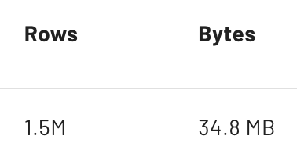

This means that all partition folders for the distinct values of the partitioned field were all read. To verify, look for the Query plan section on the same page as you are now on. If you navigated away, click on Query details then the Advanced tab.

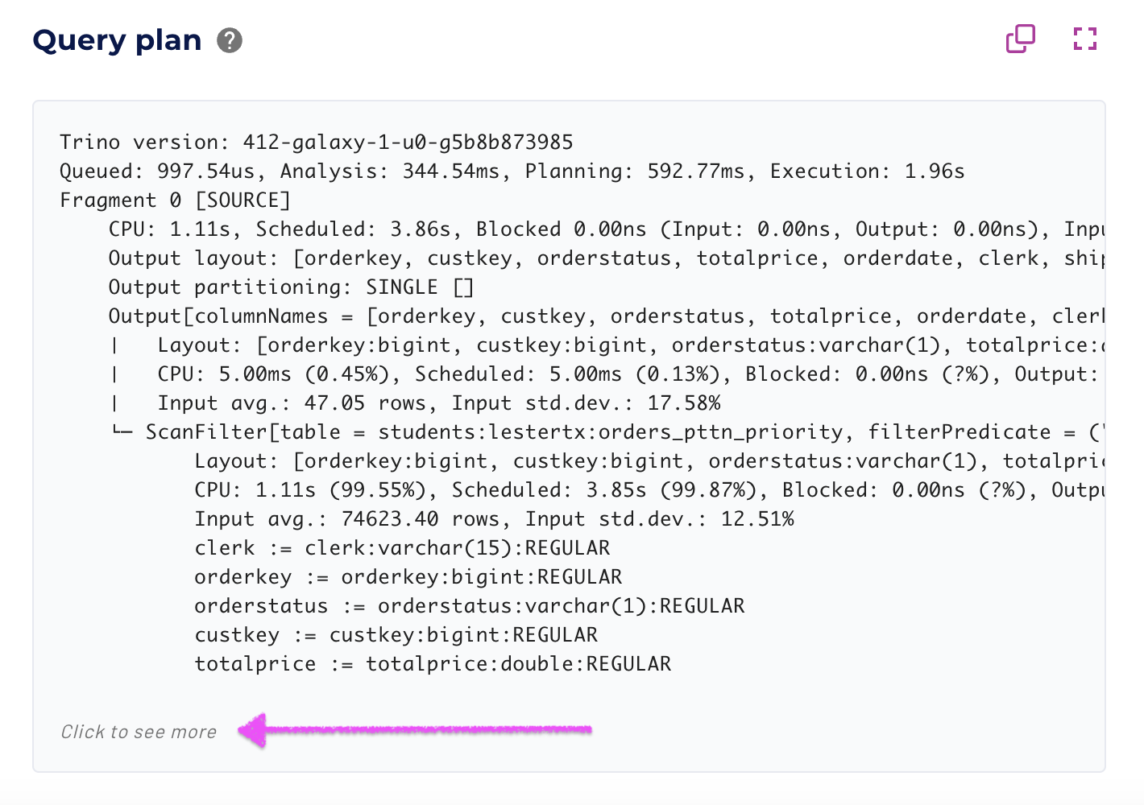

Now, click on the Click to see more link at the bottom of the Query plan section as highlighted above.

Focus on the two lines above the final output line. These should start with the partitioned_by column name.

Output

orderpriority := orderpriority:varchar(15):PARTITION_KEY
:: [[1-URGENT], [2-HIGH], [3-MEDIUM], [4-NOT SPECIFIED], [5-LOW]]

Because this is a partitioned column, the query plan will show you the folders that were read. The five above represent all of the distinct values for the orderpriority column. This is further evidence that a full table scan occurred.

Step 8 - Leverage partition pruning with partitioned orders table
Add an orderpriority filter to the query and execute it.

SELECT * from orders_pttn_priority
WHERE totalprice >= 430000.00
AND orderpriority = '4-NOT SPECIFIED';

Determine how many rows and bytes were read while executing this query.

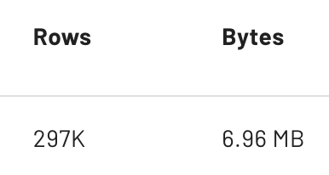

This represents about 20% of the full table scan’s metrics. The sample data we used from TPCH was relatively evenly distributed across the five order priority values which provides anecdotal evidence that only one of the partition folders was read.

Using the process described in Step 7, determine which folder(s) were read during this query’s execution.

Output

orderpriority := orderpriority:varchar(15):PARTITION_KEY
:: [[4-NOT SPECIFIED]]

This solidifies the anecdotal evidence with actual results. When the query engine can read a subset of the partition folders, this is referred to as partition pruning.

Step 9 - Using a partition column derived from a timestamp
To make the benefits of partitioning more obvious, this step will utilize a larger table holding 35 days of server logs with 101M rows.

Run the following to understand how this partitioned table was created.

SHOW CREATE TABLE lakehouse.serverlogs.logs_daily_part_csv;

Output

CREATE TABLE lakehouse.serverlogs.logs_daily_part_csv (
event_time timestamp(3),
ip_address varchar(15),
app_name varchar(25),
process_id smallint,
log_type varchar(15),
log_level varchar(15),
message_id varchar(15),
message_details varchar(555),
log_date char(10)
)
WITH (
external_location =
's3://edu-train-galaxy/serverlogs/logs_daily_part_csv',
format = 'TEXTFILE',
partitioned_by = ARRAY['log_date'],
textfile_field_separator = ',',
type = 'HIVE'
)

Note: You can see the table is partitioned on the log_date field, but there is also an event_time field. It is a common practice with Hive tables that need to be partitioned on a more coarse-grained representation of a timestamp to create a second field like this log_date example. That is to say that the log_date will always be the same for any record with an event_time for that same day.

You do not have access to review the data in S3, but here is an example of the contents of one of the 35 days (June 27 - July 31, 2021) as stored in a partition folder.

Each of the 35 days has a single file of ~ 555MB in size in their respective partition folders. This totals up to ~ 20GB of data.

Run a query attempting to leverage only three of the 35 days of data.

SELECT ip_address, log_type, log_level
FROM lakehouse.serverlogs.logs_daily_part_csv
WHERE app_name IN ('CRM', 'ERP')
AND log_type = 'THREAT'
AND log_level = 'FATAL'
AND event_time >=
from_iso8601_timestamp(
'2021-07-02T00:00:00')
AND event_time <
from_iso8601_timestamp(
'2021-07-05T00:00:00')
ORDER BY app_name, ip_address;

Determine how many records and bytes were read.

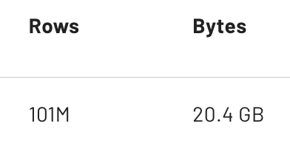

This indicates that a full table scan was performed.

Determine which directories were read.
Output

log_date:char(10):PARTITION_KEY
:: [[2021-06-27, 2021-07-31]]

This shows that an array of directories from 2021-06-27 through 2021-07-31 were read. This verifies that the entire data set was searched through.

The full table scan occurred as the query used the event_time column, not the partitioned log_date column.

Revise the query to use the column that will be leveraged more efficiently.

SELECT ip_address, log_type, log_level
FROM lakehouse.serverlogs.logs_daily_part_csv
WHERE app_name IN ('CRM', 'ERP')
AND log_type = 'THREAT'
AND log_level = 'FATAL'
AND log_date >= '2021-07-02'
AND log_date <= '2021-07-04'
ORDER BY app_name, ip_address;

Determine how many records and bytes were read.

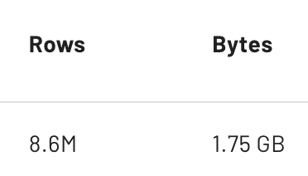

The 101M rows and 20GB of data are relatively evenly distributed across the 35 days. The query was expected to read three of the 35 folders (3/35 or 8.5% of the full data). Performing some quick calculations provides anecdotal evidence that only three of the partition folders were read.

Determine which folders were read during this query’s execution.

Output

log_date:char(10):PARTITION_KEY
:: [[2021-07-02], [2021-07-03], [2021-07-04]]

This solidifies the anecdotal evidence with actual results. The partition pruning resulted in only the three specific day’s folders being read.

Step 10 - Table scan orders searching by customer
Now, run the following query on the non-partitioned orders table to see that searching by a particular customer will result in a full table scan.

SELECT *
FROM orders_no_pttn
WHERE custkey = 130000;

Verify that all 1.5M rows were read.

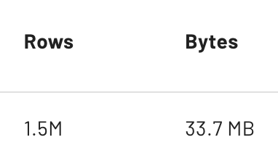

Step 11 - Create an orders table bucketed on customer
Create another table with the same data, but bucket it on the customer identifier column.

CREATE TABLE orders_bckt_custkey
WITH (
bucketed_by = ARRAY['custkey'],
bucket_count = 4,
type = 'hive'
)
AS
SELECT *
FROM tpch.sf1.orders;

You do not have access to review the data in S3, but here is an example of the contents of this table. The data was even spread by custkey into four separate files of similar size.

Adding them all up validates that a full table scan would read a similar byte count as seen in Step 10.

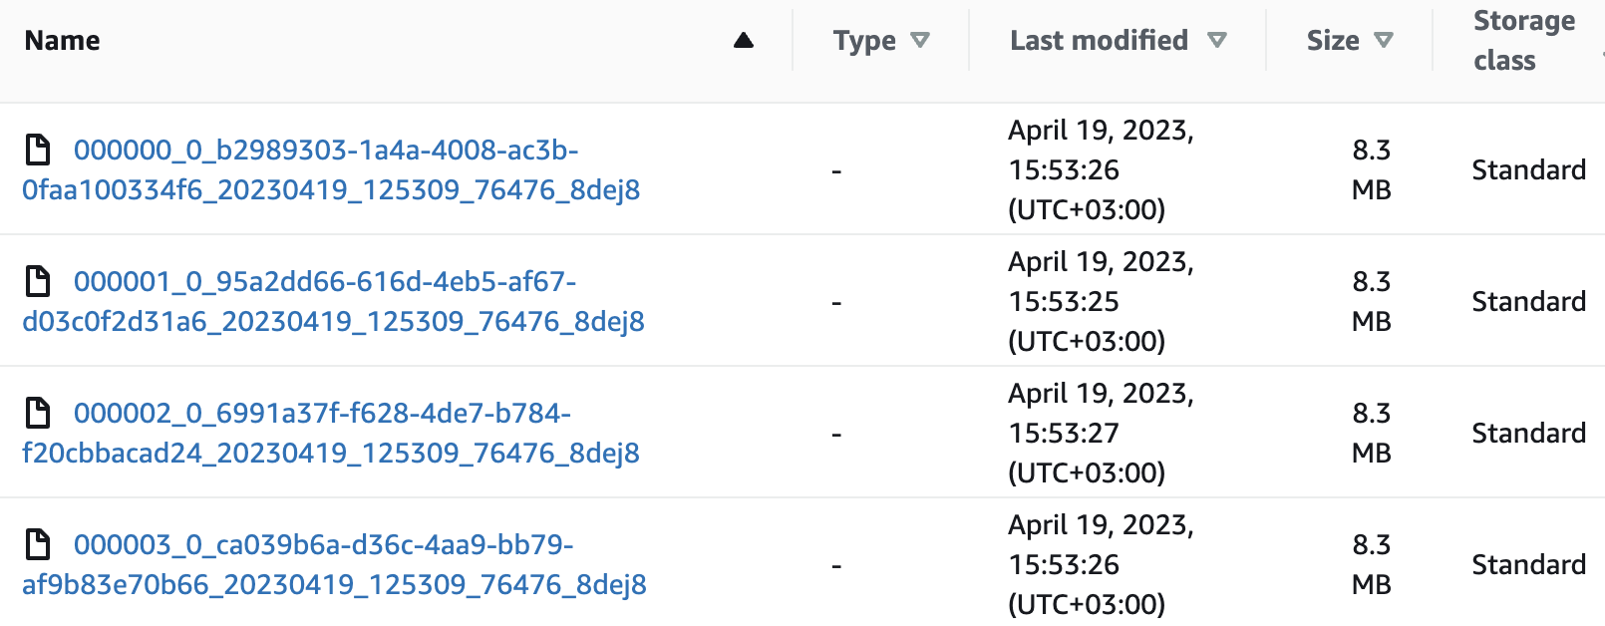

Step 12 - Read fewer files with bucketed orders table
Run the query again, but against the bucketed table.

SELECT *
FROM orders_bckt_custkey
WHERE custkey = 130000;
Determine how much data was read.

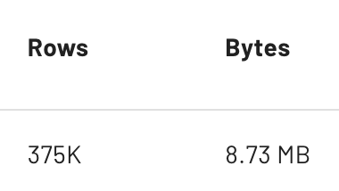

Only about 25% of the data was read because the specific custkey value could only be in one of the four buckets on the data lake.

The customer identifier would not have been a good partitioning column because there are so many unique customers and each customer only has a few orders. That would create a very small file problem. Bucketing was a better choice for this kind of performance expectation.

Remember, partitioning and bucketing can be used independently or in combination.

Summary
- You reviewed the functionality of partitioning & bucketing and how they can be used independently or together
- You determined how to tell if a full table scan was executed to complete a query
- You created a partitioned table that was designed for a particular filter
- You determined how to see if partition pruning worked as expected
- You explored strategies for when a partition needs to be created based on a more coarse-grained aspect of a timestamp
- You created a bucketed table that was designed for a particular filter
- You realized that the bucketed table only reads a single bucket/file when filtering on the bucketed column

END OF LAB EXERCISE

